|  |  |
| --- | --- |
|  | **SCIENCE : YEAR 10 : TEST**  **GLOBAL SYSTEMS** |

**NAME**: **I. M. WRIGHT** **MARKS**: /**62**

**TIME**: **52** minutes

**SECTION A: MULTIPLE CHOICE (11 marks)**

Questions 1-3 are based on the diagram of the nitrogen cycle on the right.

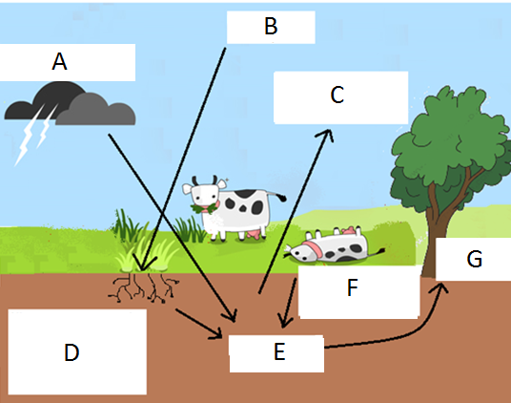

**1**. Label ‘A’ shows lightning:

(a) converting nitrates to nitrogen gas.

(b) converting nitrogen gas to nitrates.

(c) denitrifying nitrates to nitrogen gas.

(d) warming the air.

**2**. Label ‘B’ refers to:

(a) nitrogen gas in the soil.

(b) nitrates in the soil.

(c) nitrates in the atmosphere.

(d) nitrogen gas in the atmosphere.

**3**. Label ‘F’ shows:

(a) decomposers rotting a dead animal to return nitrates to the soil.

(b) nitrogen fixing bacteria converting nitrogen gas back to nitrates.

(c) nitrogen fixing bacteria converting nitrates in soil back to nitrogen gas.

(d) denitrifying bacteria converting nitrates in soil back to nitrogen gas.

**4**. The process where plants convert atmospheric carbon dioxide and water from the soil into in simple sugars (glucose) is called:

(a) respiration.

(b) transpiration.

(c) photosynthesis.

(d) transduction.

**5**. Legume plants have:

(a) root nodules for converting nitrogen gas to nitrates.

(b) root hairs that convert atmospheric carbon and water from the soil into in simple sugars.

(c) denitrifying bacteria in root nodules converting nitrates to nitrogen gas.

(d) nitrogen fixing bacteria in root nodules converting nitrates to nitrogen gas.

**6**. Identify the best description of what global warming is.

(a) periods of global warming occur between periods of glaciation

(b) greenhouse gases in the atmosphere cause global warming

(c) global warming began after the Industrial Revolution

(d) during periods of global warming sea levels fall exposing more land

**7**. Identify the statement that is supported by the data represented in the graph.

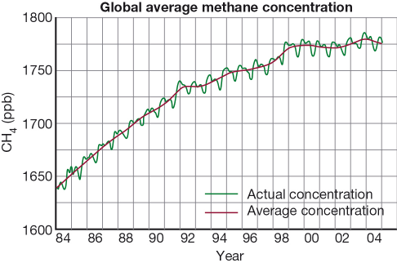

(a) The most rapid increase in methane levels in the atmosphere was from 1992 to 1998.

(b) Methane levels increased by 20% from 1984 to 2004.

(c) The concentration of methane in the atmosphere decreased from 1997 to 2004.

(d) There is an annual variation in methane concentration that follows a similar pattern each year.

1. **8**. Using the information in the graph below, calculate the average yearly increase in temperature from the year 1980 to 2007.

(a) 0.38°C

(b) 0.29°C

(c) 0.12°C

(d) 0.014°C

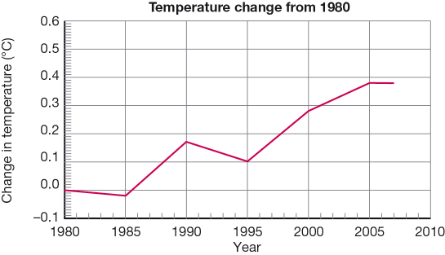

1. **9**. Using the graph in question 8, deduce the period when the temperature was increasing most rapidly.

(a) 1980 to 1985

(b) 1985 to 1990

(c) 1995 to 2000

(d) 2000 to 2005

**10**. Which statement does NOT describe the Southern Oscillation?

(a) During El Niño events the Southern Oscillation Index (SOI) is strongly negative. During La Niña the SOI is strongly positive.

(b) The Southern Oscillation has most effect on weather in central and southern Australia.

(c) The SOI is a measure of the atmospheric and ocean conditions across the Pacific Ocean.

(d) Where there is no El Niño or La Niña winds blow from the western Pacific Ocean to the east bringing average rainfall to Australia.

**11**. Identify Earth’s largest and oldest long-term store of carbon.

(a) rainforest trees

(b) calcium carbonate

(c) fossil fuels

(d) carbon dioxide

**SECTION B: SHORT ANSWER (51 marks)**

**1.** Explain the difference between weather and climate. (2 marks)

____________________________________________________________________________________

**Weather describes the state of the atmosphere in terms of temperature,**

____________________________________________________________________________________

**wind, cloud cover and precipitation.**

____________________________________________________________________________________

**Climate is the long-term averages of weather conditions. Average statistics using 30**

____________________________________________________________________________________

**years of weather records and including extreme events are used to describe the**

____________________________________________________________________________________

**climate of an area.**

____________________________________________________________________________________

**2.** Explain why plants can suffer from a lack of nitrogen despite being surrounded by air that is 78% nitrogen. (2 marks)

____________________________________________________________________________________

**Most living things are not able to make use of nitrogen in the form of a gas**

____________________________________________________________________________________

____________________________________________________________________________________

____________________________________________________________________________________

____________________________________________________________________________________

**3.** Label the different spheres in the diagram below. (2 marks)

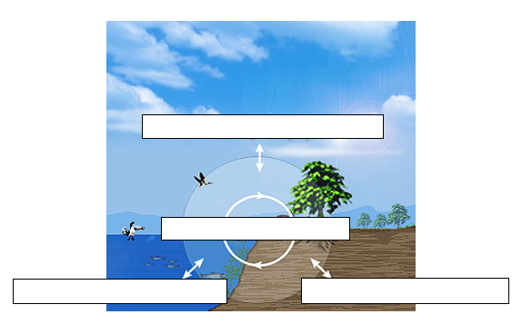

**Atmosphere**

**Biosphere**

**Land**

**Sea**

**Hydrosphere**

**Lithosphere**

**Atmosphere**

**4.** Explain why those areas of the Earth’s surface covered in ice do not warm as fast as those areas covered by dark forests? (4 marks)

____________________________________________________________________________________

Areas covered in ice are lighter in colour and reflect more heat.

____________________________________________________________________________________

Areas covered in dark forests are darker in colour and absorb more heat.

____________________________________________________________________________________

____________________________________________________________________________________

____________________________________________________________________________________

____________________________________________________________________________________

____________________________________________________________________________________

**5.** One suggested way of reducing the impact of carbon emissions is to plant more trees. Explain why this would be a useful strategy. (2 marks)

____________________________________________________________________________________

*Tree take in carbon dioxide (CO2) and use it in photosynthesis*

____________________________________________________________________________________

____________________________________________________________________________________

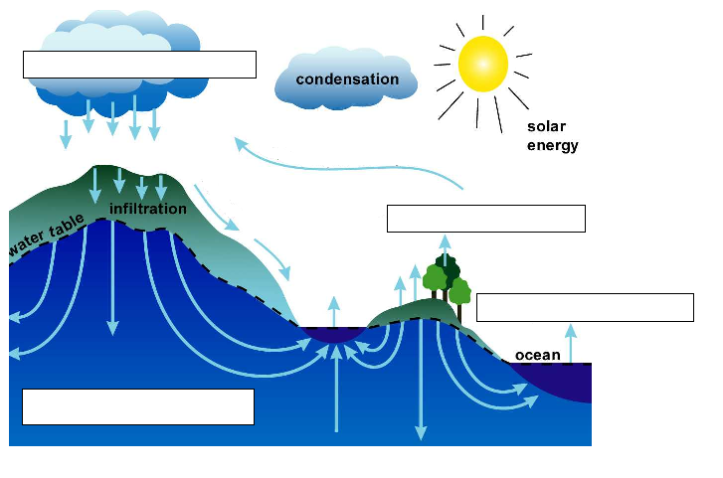**6.** Label the diagram of the water cycle shown below. (4 marks)

**EEvaporation**

**PPercolation**

**ACondensation**

**APrecipitation**

**7.** Name four (4) of the main greenhouse gases. (4 marks)

i) **Water vapour**

___________________________________________________________________________________

ii) **Carbon dioxide**

___________________________________________________________________________________

iii) **Methane**

___________________________________________________________________________________

iv) **Nitrous oxide** **and Ozone**

___________________________________________________________________________________

**8.** Identify two (2) general ways in which greenhouse gases can be reduced.

(General methods only, not specific methods like planting trees) (2 marks)

____________________________________________________________________________________

**Reduce production. Remove from the atmosphere and store.**

____________________________________________________________________________________

____________________________________________________________________________________

____________________________________________________________________________________

**9**. Round-the-world sailors usually follow the route shown in the Figure below. The loop in the Atlantic Ocean is to make the total distance equal to sailing around the equator, which is obviously impossible because of the land. **Propose** why sailors from west to east and not the other way around. (2 marks)

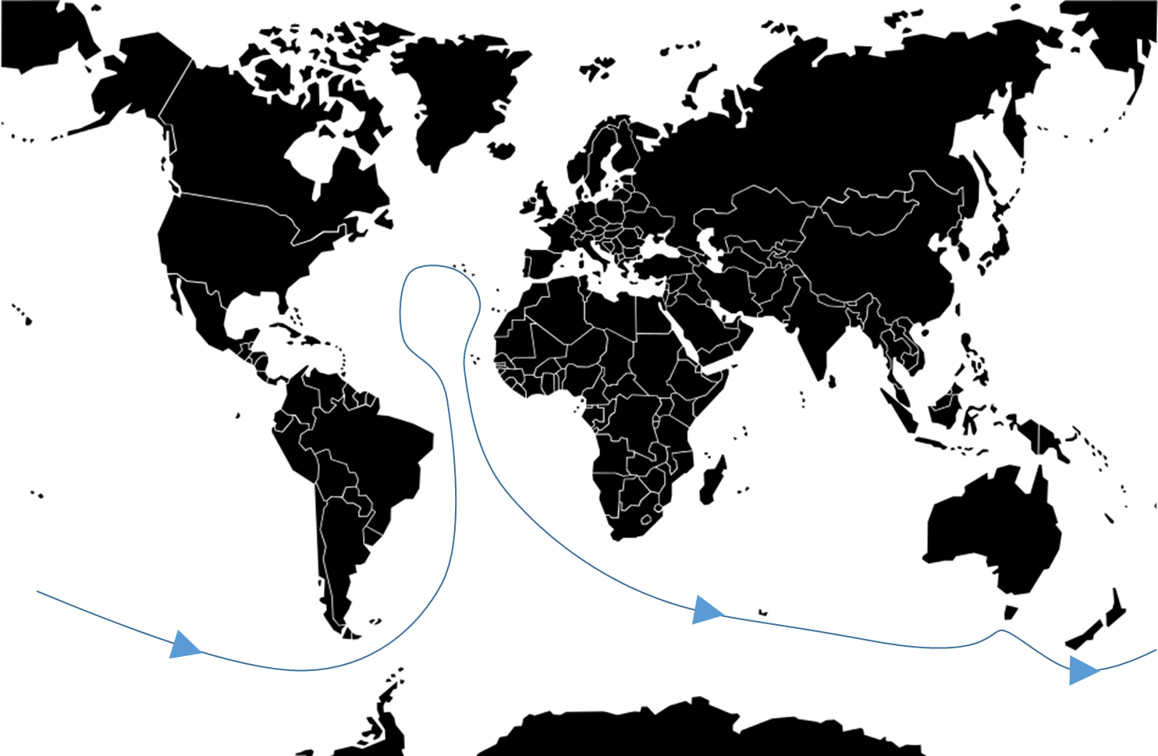

____________________________________________________________________________________

**Surface currents and the trade winds that cause them will assist the**

____________________________________________________________________________________

**sailors as they move in that direction**

____________________________________________________________________________________

____________________________________________________________________________________

____________________________________________________________________________________

____________________________________________________________________________________

**10**. Outline the relationship between interglacials and global warming. (2 marks)

____________________________________________________________________________________

**Interglaials are periods of global warming**

_______ _____________________________________________________________________________

____________________________________________________________________________________

____________________________________________________________________________________

**11.** Match the terms to their definitions by writing the number of the correct definition in the box.(10 marks)

|  |  |  |  |
| --- | --- | --- | --- |
|  | **TERM** |  | **DEFINITION** |
| **7** | Enhanced greenhouse effect | 1. | All the liquid water on the Earth’s surface. |
| **8** | Biosphere | 2. | The warming of the Earth caused by greenhouse gases. |
| **1** | Hydrosphere | 3. | Land masses on Earth. |
| **2** | Greenhouse effect | 4. | The preserved remains of once-living organisms. |
| **5** | Atmosphere | 5. | The layers of gases surrounding the planet. |
| **4** | Fossils | 6. | A time when the average world temperature is increasing. |
| **6** | Global warming | 7. | Increase in the natural greenhouse effect caused by human activity. |
| **10** | Fossil fuels | 8. | All living things on Earth. |
| **3** | Lithosphere | 9. | The variety of ecosystems in the biosphere, the variety of species within those ecosystems and the genetic variation within those species. |
| **9** | Biodiversity | 10. | Fuels that contain the carbon of plants and animals that died and were preserved millions of years ago. |

**12**. List three (3) factors that affect the world’s climate. (3 marks)

____________________________________________________________________________________

**Sun, the amount of cloud, amount of ice, forests, concentration of greenhouse**

____________________________________________________________________________________

**gases in the atmosphere, tilt of the Earth’s axis.**

____________________________________________________________________________________

____________________________________________________________________________________

**13**. Refer to the **Figure** below. The diagram represents part of the carbon cycle. (3, 2 = 5 marks)

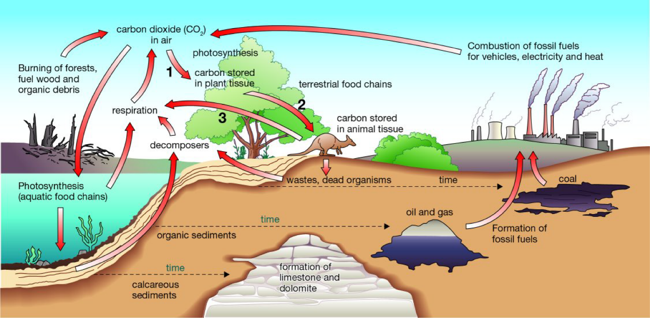

**a Construct** a statement for each of the numbered arrows, describing what happens at that step.

1. ______________________________________________________________________________

**Plant uses carbon dioxide (CO2) in photosynthesis.**

_____________________________________________________________________________

_____________________________________________________________________________

2. ______________________________________________________________________________

**Plants become food for herbivores; carbon compounds present**

_____________________________________________________________________________

**in plants become incorporated into animals’ tissues.**

_____________________________________________________________________________

3. ______________________________________________________________________________

**Cellular respiration produces CO2 as a by-product, which is released**

_____________________________________________________________________________

**back into the atmosphere.**

_____________________________________________________________________________

**b Explain** why the recycling of materials is important to the continued functioning of ecosystems.

____________________________________________________________________________________

**Recycling of materials ensures that substances become available again for use by plants and**

____________________________________________________________________________________

**animals in the ecosystem. If materials were not recycled but were locked up in the dead**

____________________________________________________________________________________

**remains of plants and animals, fewer and fewer resources would be available for new organisms.**

____________________________________________________________________________________

**Eventually life would cease to exist.**

____________________________________________________________________________________

**14**. Human activities have added extra carbon dioxide to the atmosphere, putting the carbon cycle out of balance. Propose four (4) likely effects from a continued increase in levels of atmospheric carbon dioxide. (4 marks)

Adding CO2 to the atmosphere is likely to cause increased average world temperatures. Possible flow-on effects include:

i) **rises in global sea levels**

___________________________________________________________________________________

ii) **more droughts, floods, cyclones and typhoons, with resultant crop failures leading to political and social upheaval**

___________________________________________________________________________________

iii) **an increase in the incidence of diseases such as malaria, dengue fever and cholera**

___________________________________________________________________________________

iv) **changes in vegetation zones or changes in ecosystem diversity and stability**

___________________________________________________________________________________

1. **15. Explain** how each of the following can be used as evidence of climate past change. (3 marks)

**a**  ice cores

**On some glaciers and ice sheets, sufficient snow falls each year to form recognisable annual layers.**

_________________________________________________________________________________

**Scientists take cores from the ice and then analyse its physical and chemical properties.**

_________________________________________________________________________________

**The analysis provides information about temperatures and the composition of the air**

_________________________________________________________________________________

**from hundreds of thousands of years in the past.**

**b** sedimentary rocks

**The worldwide distribution of sedimentary rocks and the types of fossils found in them**

_________________________________________________________________________________

**are indicators of changes in sea level in the past. For example, sedimentary rocks in the**

_________________________________________________________________________________

**dry area of central Australia contains fossils of sea creatures.**

_________________________________________________________________________________

**c**  glaciers

_________________________________________________________________________________

**Glaciers advance when the climate cools and retreat when the climate warms.**

_________________________________________________________________________________

_________________________________________________________________________________